# Sun spots data set.

# Regression comparison between models.

Exercise 3: Linear model

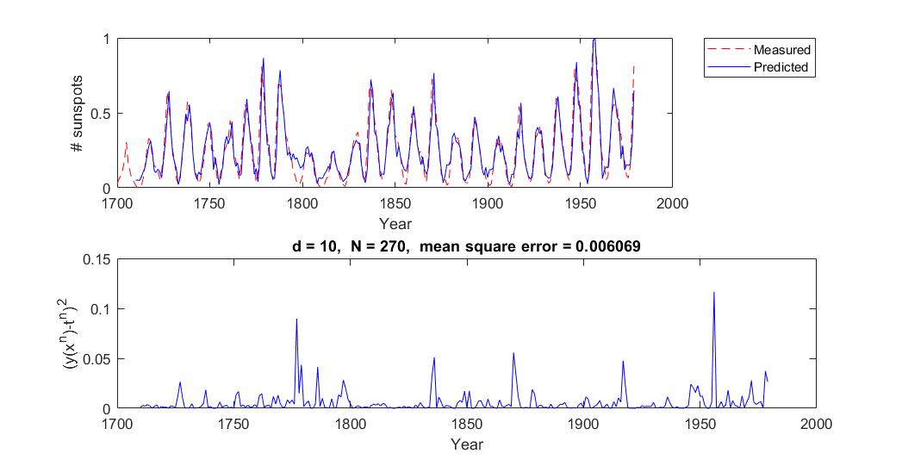

No test set implemented in this exercise, which makes comparisons more difficult.

Exercise 4: Linear model with weight decay

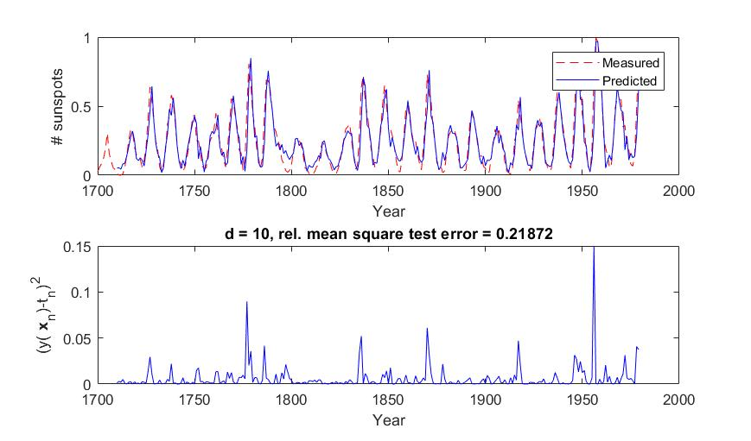

Exercise 8: Density function estimator

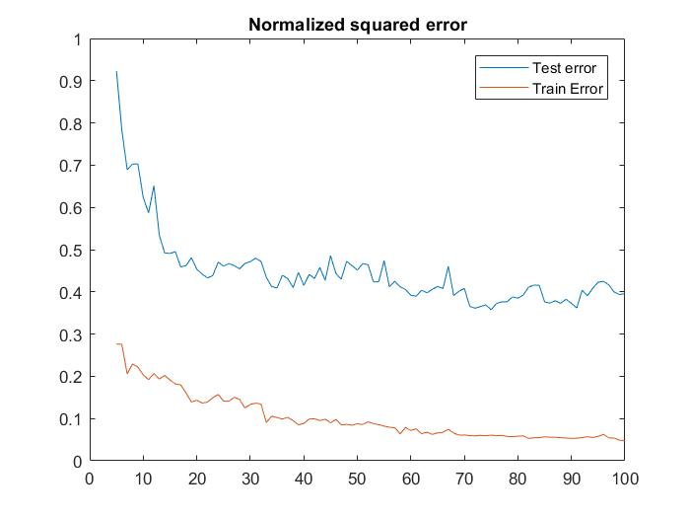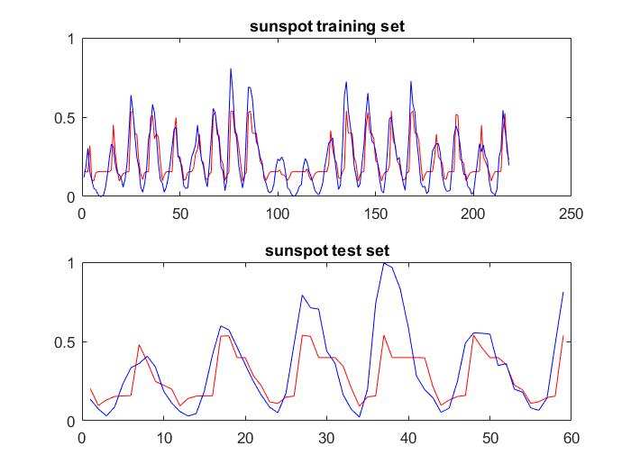

Exercise 9: KNN

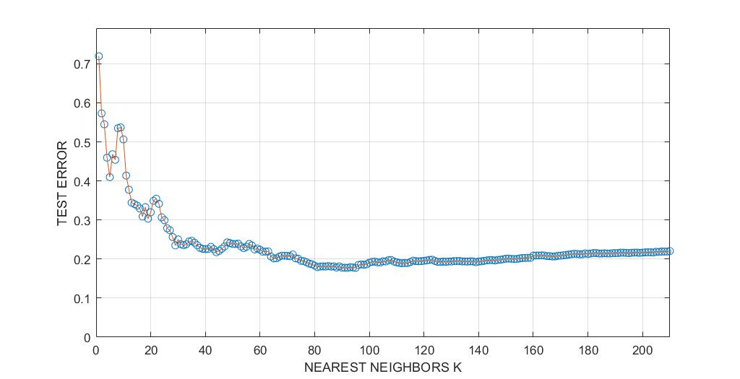

Exercise 10: Gaussian process estimator

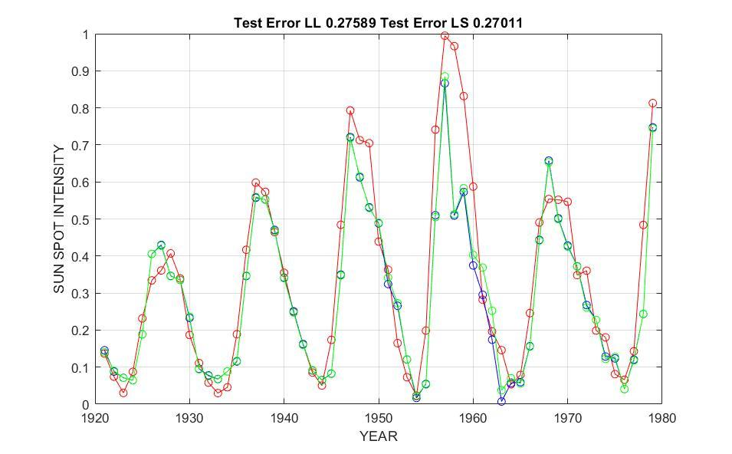

Exercise 12: Dynamical linear system

